Mano basic computer
Instruction format of basic computer
15 mode bit(I) | 12-14 opcode 4bit | 0-11 address 12bit

Addressing mode in basic computer:
When I = 0 → direct addressing mode (the address in operand field is effective address)
When I = 1 → indirect addressing mode (the address in operand field contains memory address where effective address resides)

Types of instructions:
1. Memory reference instruction
2. Register reference instruction
3. I/O reference instruction

Memory reference instructions:
Symbol | I = 0 | I = 1 | Description
AND | 0xxx | 8xxx | AND memory word to AC
ADD | 1xxx | 9xxx | add memory word to AC
LDA | 2xxx | Axxx | Load AC to memory
STA | 3xxx | Bxxx | Store AC content to memory
BUN | 4xxx | Cxxx | Branch unconditionally
BSA | 5xxx | Dxxx | Branch and store return address
ISZ | 6xxx | Exxx | Increment and skip if 0

Register Reference instructions:
15-12 0111 | 11-0 register operation

Symbol | hexcode | description
CLA | 7800 | Clear AC
CLE | 7400 | Clear E flag
CMA | 7200 | Complement AC
CME | 7100 | Complement E flag
CIR | 7080 | Circulate right AC and E
CIL | 7040 | Circulate left AC and E
INC | 7020 | Increment AC
SPA | 7010 | Skip next instruction if AC is +ve
SNA | 7008 | Skip next instruction if AC is -ve
SZA | 7004 | Skip next instruction if AC is 0
SZE | 7002 | Skip next instruction if E flag is zero
HLT | 7001 | Halt computer

I/O reference instructions:
15-12 1111 | 11-0 I/O operation

Symbol | Hex code | description
INP | F800 | Input character to AC
OUT | F400 | Output character form AC
SKI | F200 | Skip on input flaag
SKO | F100 | Skip on output flag
ION | F080 | Interupt on
IOF | F040 | Interupt off

For an instrucction set of a CPU to be complete it must must have the folloeing instructions:
1. Data manipulation instructions
→ Arithmatic instructions (ADD, SUB, INC, DEC, etc)
→ Logical instructions (AND, OR, XOR, etc)
→ Shift instructions (SHR, SHL, etc)

2. Data transfer instructions (MOV, LDA, STA, etc)

3. Branching instructions (BUN, BSA, ISZ, etc)

4. I/O instructions (INP, OUT, etc)

Hardwired Control Unit:
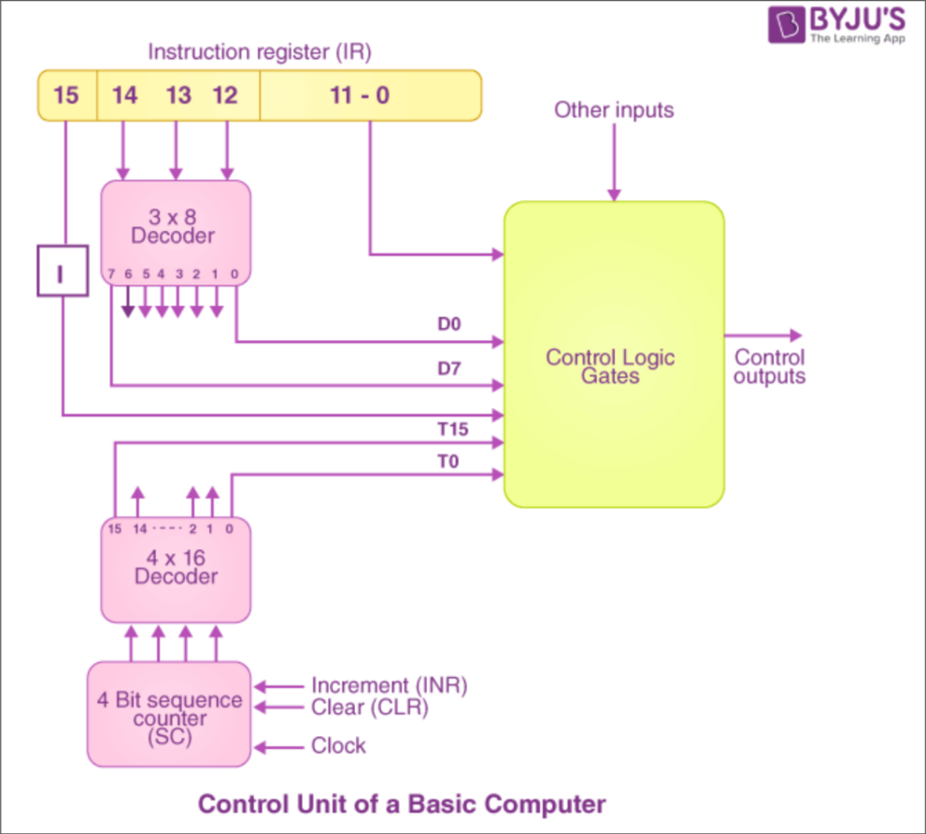

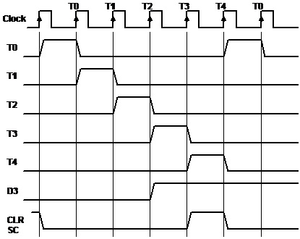

Timing diagram for D3T4 : SC ← 0

Instruction cycle:
1. Fetch Instruction
2. Decode Instruction
3. Catlculate Operand Address (read the effective address from the memory if the instruction has indirect address)
4. Execute Instruction

Fetch:
T0 : AR ← PC
T1 : IR ← M[AR] , PC ← PC + 1

Decode:
T2 : D0 , … , D7 ← Decode IR(12-14) , AR ← IR(0-11) , I ← IR(15)

Flowchart:
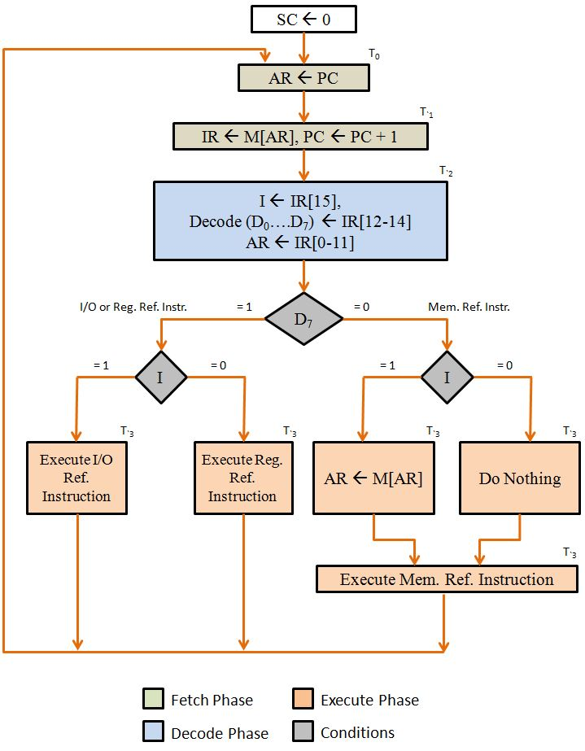

Register reference instructions:
D7 = 0 , I = 0
→ reg ref instructions are specified in bits b₀ – b₁₁ IR
→ execution starts in time T3
Let r = D7I’T3 common to all register reference instructions
B_{i} = IR(i) i = 0,1,2,…,11
CLA = rB₁₁ AC ← 0 , SC ← 0
CLE = rB₁₀ E ← 0 , SC ← 0
CMA = rB₉ AC ← AC’ , SC ← 0
CME = rB₈ E ← E’ , SC ← 0
CIR = rB₇ AC ← shrAC , AC(15) ← E , E ← AC(0) , SC ← 0
CIL = rB₆ AC ← shrAC , AC(0) ← E , E ← AC(15) , SC ← 0
INC = rB₅ AC ← AC + 1 , SC ← 0
SPA = rB₄ if(AC(15)=0) then PC ← PC + 1 , SC ← 0
SNA = rB₃ if(AC(15)=1) then PC ← PC + 1 , SC ← 0
SZA = rB₂ if(AC=0) then PC ← PC + 1 , SC ← 0
SZE = rB₁ if(E=0) then PC ← PC + 1 , SC ← 0
HTL = rB₀ S ← 0 , SC ← 0

Memory reference instructions:
AND D0 AC ← AC ^ M[AR]
ADD D1 AC ← AC + M[AR]
LDA D2 AC ← M[AR]
STA D3 M[AR] ← AC
BUN D4 PC ← AR
BSA D5 M[AR] ← PC , PC ← AR + 1
ISZ D6 M[AR] ← M[AR] + 1 , IF M[AR] + 1 =0 THEN PC ← PC + 1

AND
D₀T₄ = DR ← M[AR]
D₀T₅ = AC ← AC ^ DR , SC ← 0
ADD
D₁T₄ = DR ← M[AR]
D₁T₅ = AC ← AC + DR , SC ← 0
LDA
D₂T₄ = DR ← M[AR]
D₂T₅ = AC ← DR , SC ← 0
STA
D₃T₄ = M[AR] ← AC , SC ← 0
BUN
D₄T₄ = PC ← AR , SC ← 0
BSA
D₅T₄ = M[AR] ← PC , AR ← AR + 1
D₅T₅ = PC ← AR , AC ← 0
ISZ
D₆T₄ = DR ← M[AR]
D₆T₅ = DR ← DR + 1
D₆T₆ = M[AR] ← DR , IF(DR=0) THEN (PC ← PC + 1) , SC ← 0

